Story of Positive Impact on Group of Beneficieries
Project : KfW Soil Project

- Project Village :- Lachhnadih
- Farmer’s Name and Mob. No.- Nuneshwar Yadav-7242091383, Rudo Yadav-9560339136, Talo Yadav-9631478377, Ramphal Yadav-90061622024, Pankaj Yadav-8002134801 and others.

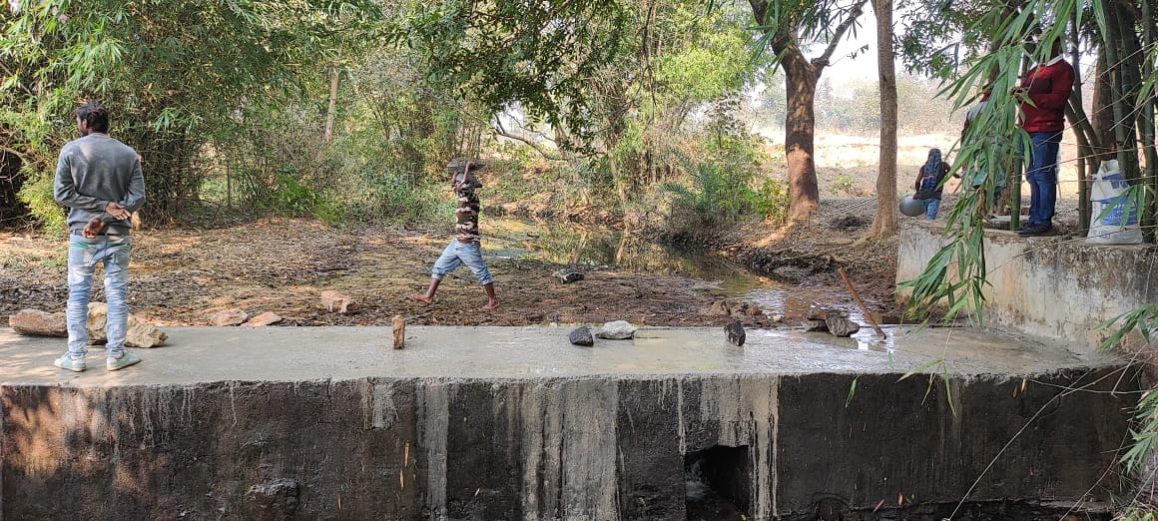
- Address :- At - lachhnadih , PO- Mothabari, PS- Katoria, Dist.- Banka Pin - 813106
- Name of Activity:- Renovation of Check Dam Lachhnadih
- Month of Initiation:- December 2021
- Problem Statement :-
A hilly rivulet flows by the side of the village. During the implementation of watershed Development Project of NABARD a Check dam was constructed. It was very useful but it was damaged and irrigation of land stopped resulting into low production and no production.

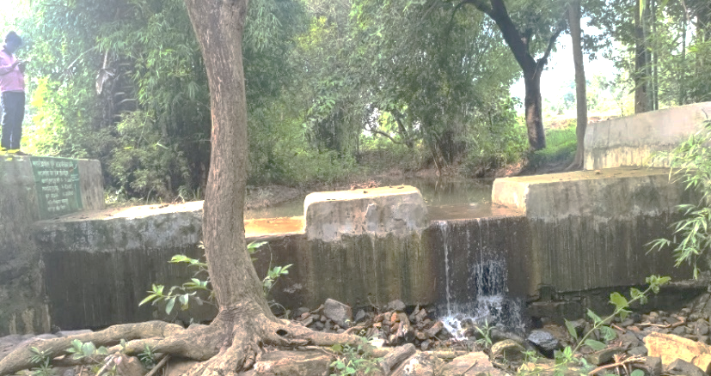
- Initiation Taken :-
This time Under KfW Soil Project renovation was done. At damaged portions the wall was raised from the foundation. Proper boulders, Chips, sand and cement were used to complete up the main wall. Wings on both sides were raised. The hight of the main wall and wing wall were properly prepared. The total wall was plastered and decorated. The slit of the bed was removed. The weeds were uprooted away. Neat and clean repaired check dam was ready.
The flush plug was closed. Running water of the river collected and farmers began to reuse.

- Progress And Result :-
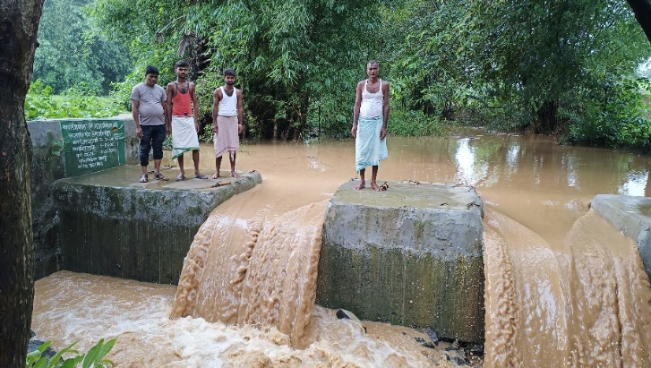
The Present Year 2022 has been a dry year. Monsoon failed completely. But farmers of Lachhanadih sowed maize, vegetables and even paddy seeds. To some extent paddy transplantation is also done. Water for all season crop is available abundantly.
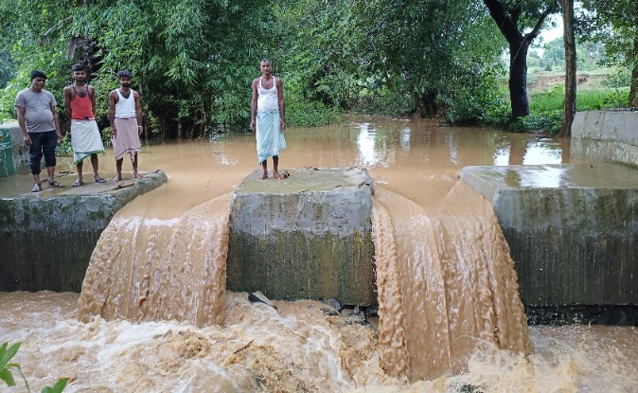
- Impact:-
The whole village looks green due to full of crops. Income of farmers certainly has been low but not nill as in side by villages. All farmers have raised kitchen gardens and they are not adding sufficient nutritious vegetables in their food only, they are selling vegetables for their additional income. Really 24 farmers families are utilizing the benefit.

- Inspiration :-
Water Management is essential for irrigation which includes harvesting, collecting, distributing and recycling.

